|  |
| --- |
|  |
| **Unlocking Sales & Profit Potential: A Financial Dashboard Analysis** |
| |  |  |  | | --- | --- | --- | | Hardik Lalwani | 10/23/24 | [Course title] | |

**Table of Contents**

1. Introduction 2

2. Key Insights from the Dashboard 2

1. Total Sales Over Time: 2

2. Sales by Product 2

3. Profit Contribution by Segment 3

4. Products by Profit 4

5. Sales by Segment 5

Sales & Profit Insights Dashboard 6

1. Introduction

The Financial Metrics Dashboard has been designed to track information about the sales and profits earned by the company and the various effects that apply here, such as discounts and performance by a specific product. Using Tableau, we visualize some key performance indicators (KPIs) through these interactive dynamic graphs to enable better decision-making.

# 2. Key Insights from the Dashboard

Now here, we are going to describe the insights that you can get through different visualizations in the dashboard.

## 1. Total Sales Over Time:

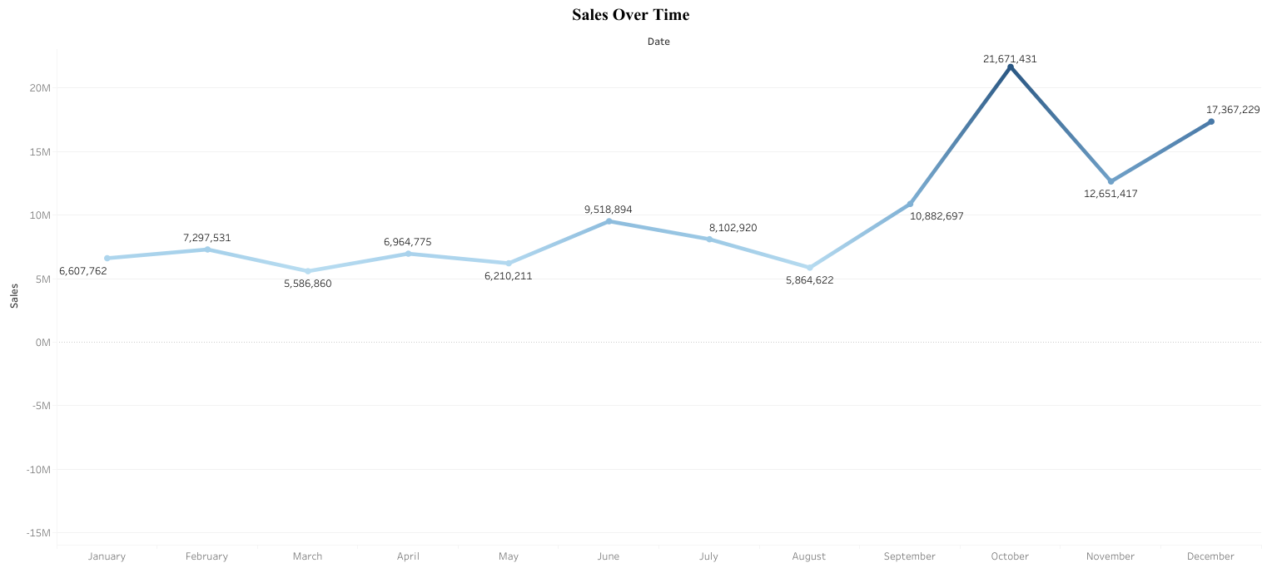

**Procedure**

In the line chat above it shows monthly sales from Jan-Dec. We plot the total sales on the Y-axis and months on the X-axis, connecting them based on monthly trends. The labels show the number of sales per month The gradient color line represents the difference in sales volume.

**Benefits**

* **Trends**: Enables tracking of sales performance over months.
* **Peaks & Lows**: Indicates the sales high (November with $21.67M) and low in March
* **Simple Comparison**: The comparison made between the monthly sales value.

**Conclusion:**November saw a big jump in sales, followed by another decline in December. A line chart that will help you find the seasonal trends and periods of low sales so that you can formulate more effective strategies when it comes to promotion or allocation of key resources

## 2. Sales by Product

**Procedure**

A Pareto chart shows total sales by product (bars) and the cumulative percentage of sales (line). Based on sales, products are ordered from highest to lowest; then cumulative percentages of total sales are calculated to find major contributors.

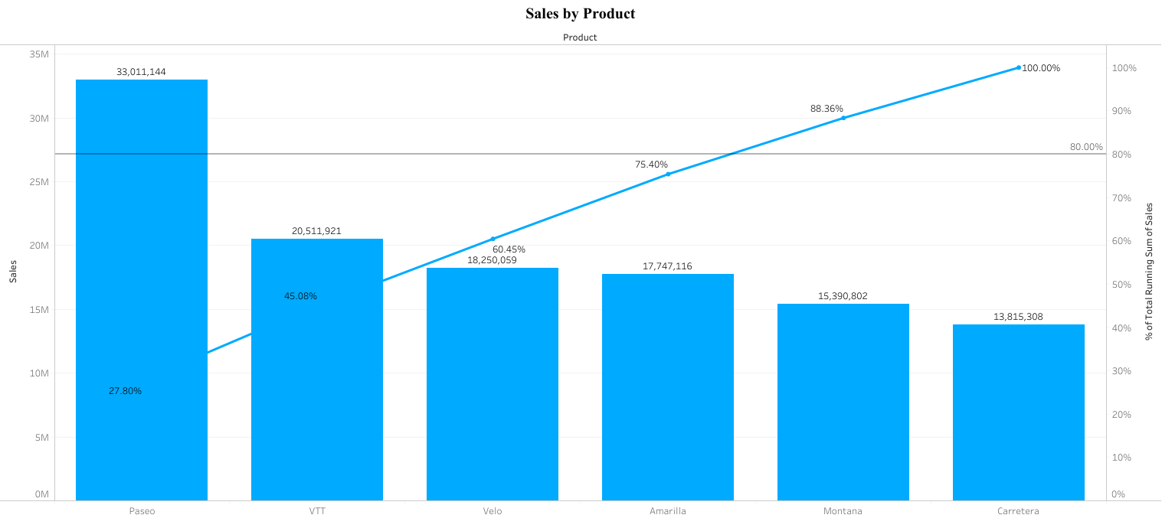

**Benefits**

* **80/20 Rule:** Highlights the top 3 products (Paseo, VTT, Velo), which contribute about 75% of sales.
* **Actionable Insight:** Focuses on high performers for better resource allocation and marketing.
* **Quick Overview:** Combines product sales and cumulative contribution for a clear, comprehensive view.

**Conclusion**

This chart shows that the sales are concentrated around a few products, with Paseo making for more than 27% of total sales by itself. This will help make sure that maximum revenue impact is obtained for the top original products.

## 3. Profit Contribution by Segment

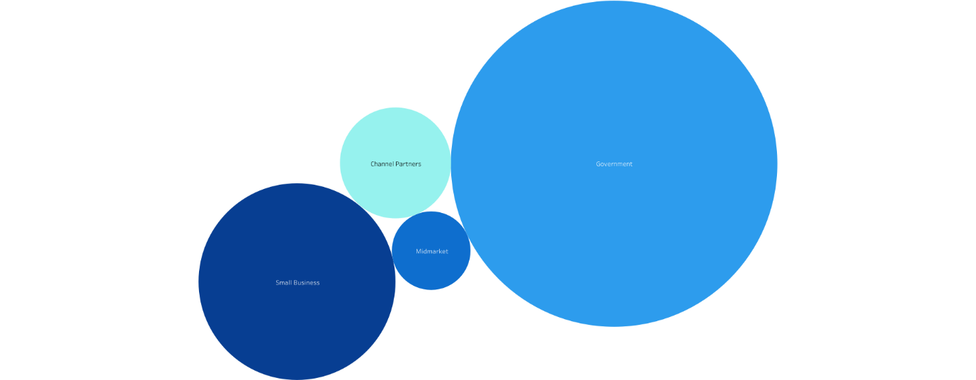

**Procedure**

A bubble chart that shows the profitability by segments; each of which is synonymous with the sizes of bubbles to the profits gained in that segment. A big size illustrates a large profit, thus smaller bubbles indicate less profit contribution. The different segments that were represented in the chart are Government, Small Business, Enterprise, Channel Partners, and Midmarket.

**Benefits**

* **Profit Distribution Insights:** This chart explains which is the more and less profitable business segment since the Government contributed the most to profit.
* **Proportional Comparison:** Through the use of bubble sizes, this chart will provide you with a proportional view of profit contributions so that you can clearly distinguish between high-performing segments and low-performing segments.
* **Visual Appeal:** You can glance and quickly know at what level varied segment-based profit performance is which helps to drive profitability with the help of this chart.

**Conclusion**

Out of these four, the contribution to the profits is the maximum in the Government segment, followed by Small Business and Enterprise. The Channel Partners and Midmarket make the least contributions at the farthest end. In terms of proportions, it would appear that even though some segments dominate, others deserve strategic attention to optimize profitability.

## 4. Products by Profit

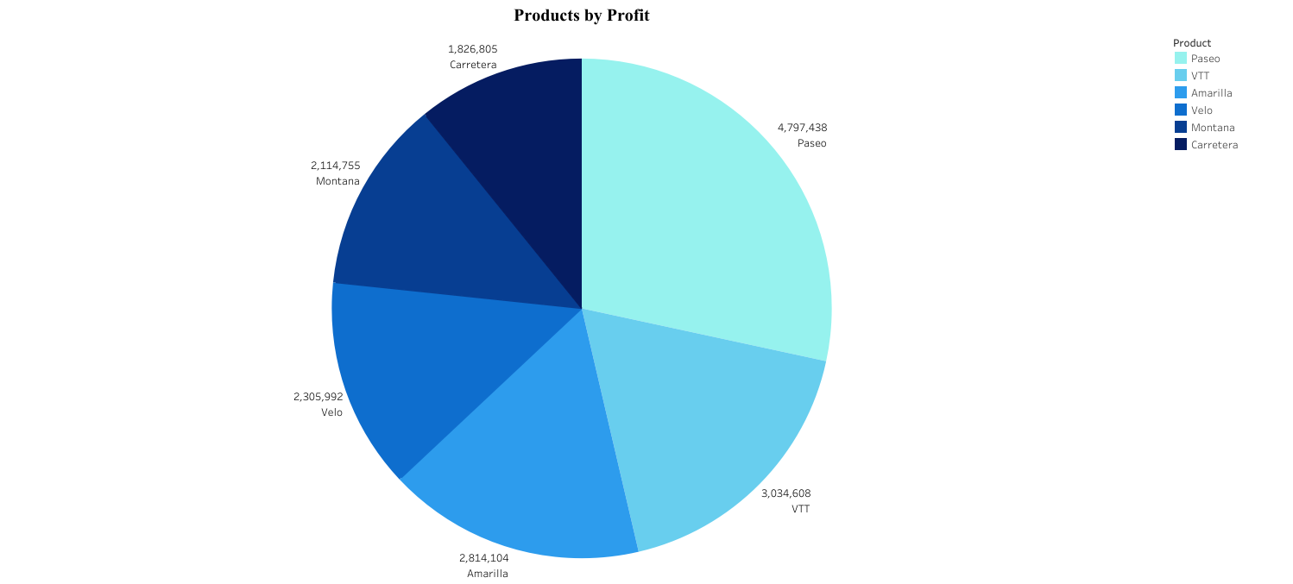

**Procedure**

This pie chart breaks down the profit contribution of each product. Each slice is proportional to the product's total profit, with **Paseo** being the largest contributor, followed by **VTT** and **Velo**. Each segment is labeled with its respective profit value.

**Benefits**

* **Profit Distribution:** The profit contribution of every product will be evident clearly, making it easy to identify the high performers and the low performers.
* **Focus Areas**: High-margin products include **Paseo and VTT**. This is the slice where the highest amount has been made from one slice and, therefore, is a possible area for more investment. A smaller slice, on the other hand, would be Carretera and Montana. Hence, there should be some review or improvement.
* **Visual Simplicity**:  It shows what was profitable by pie chart, with a clear breakdown.

**Conclusion**

The chart above highlights Paseo as the most profitable product because it attracts more than any of the other products. Hence, emphasis that marketing and operational efforts should be channeled towards Paseo and VTT to maximize profit. In this regard, other products such as Carretera and Montana may need optimization strategies to increase profitability.

## 5. Sales by Segment

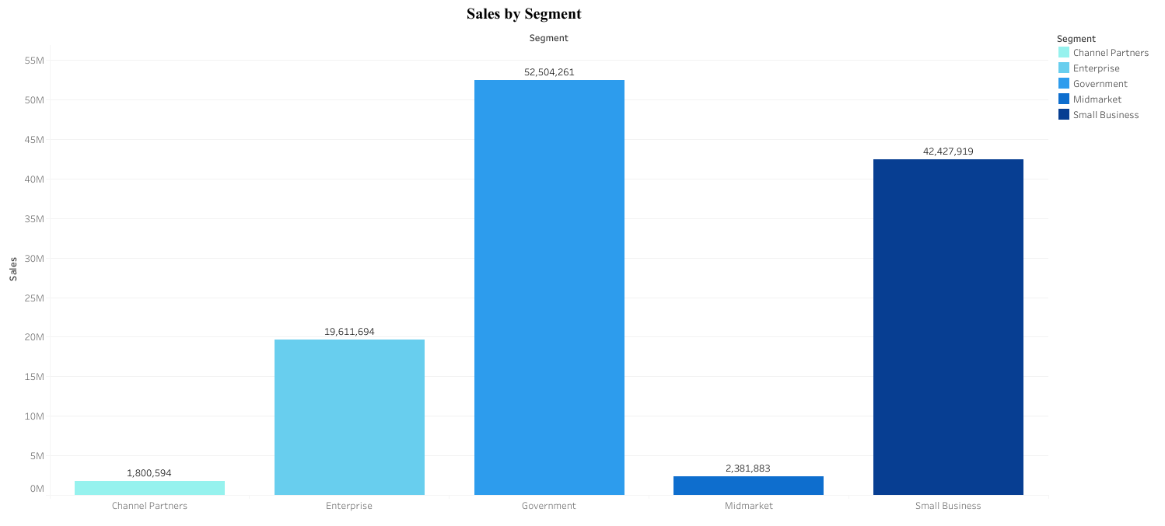

**Procedure**

In this bar graph, the bar chart is presented to show the quantity of sales for each business activity. Sectors included are Channel Partners, Enterprise, Government, Midmarket, and Small Business. Every bar is supposed to represent the total sales value of each sector, with sales figures inscribed at the top of those bars.

**Benefits**

* **Segment Comparison**: The revenue contribution of the most profitable segments is emphasized. Government comes out as the leader at $52.5M, followed by Small Business at $42.4M in sales.
* **Focus for Growth**: It is well differentiated from what each segment contributed for very easy comparison.
* **Strategic Decision-Making**: This will help determine which revenue is mostly contributed and therefore where to focus on the marketing efforts.

**Conclusion**

The Government and Small Business segments have the biggest volumes of sales while the other categories such as Channel Partners and Midmarket have relatively lower volumes of sales. Data analysis of the current demand for sales will require a particular emphasis on governmental and small business segments should be given, and the strategy of increased sales volume in Channel Partners and Midmarket categories needs to be refined.

# Sales & Profit Insights Dashboard

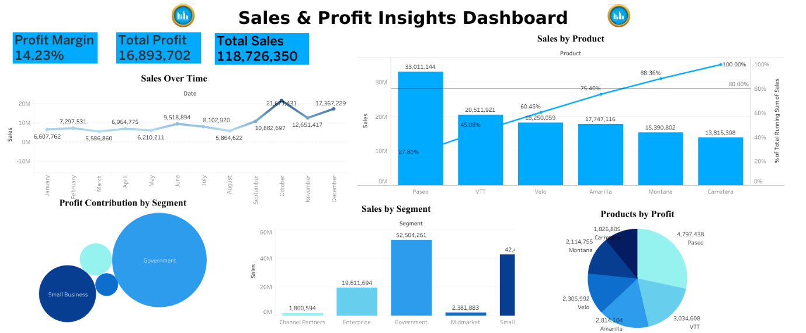

This dashboard, however, gives a picture of important financial metrics. Those are 14.23% profit margin, total profit at $16.89M, and total sales at $118.73M. From these statistics, the seasonal trends in sales can easily be detected, as well as which products are driving the revenue if discounted.

**Key Takeaways:** Focus on the best-selling products and segments, in particular Paseo and Government, to always be on profit-maximizing for PTSM; management of discounting strategy and dealing with sales variability are essential levers for maintaining sustainable growth.

You can also refer to the interactive **Sales & Profit Insights Dashboard** as accessed below [Tableau Dashboard](https://public.tableau.com/authoring/SalesOverTIme_17296238538620/Dashboard#1)